2.50: a) From Eq. (2.15), the velocity v₂ at time t

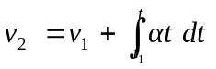

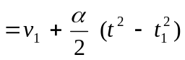
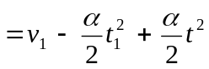
= (5.0 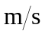) – (0.6 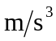)(1.0 s)² + (0.6 ) t²
= (4.40 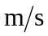) + (0.6 ) t².

At t₂ = 2.0 s, the velocity is v₂ = (4.40 ) + (0.6 )(2.0 s)² = 6.80 m/s, or 6.8 to two significant figures.
b) From Eq. (2.16), the position x₂ as a function of time is

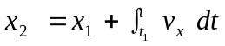
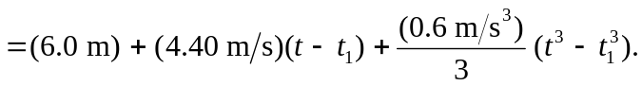
At t = 2.0 s, and with t₁ = 1.0 s,

x = (6.0 m) + (4.40 )((2.0 s) – (1.0 s)) + (0.20 )((2.0 s)³ – (1.0 s)³)
= 11.8 m.

c)
